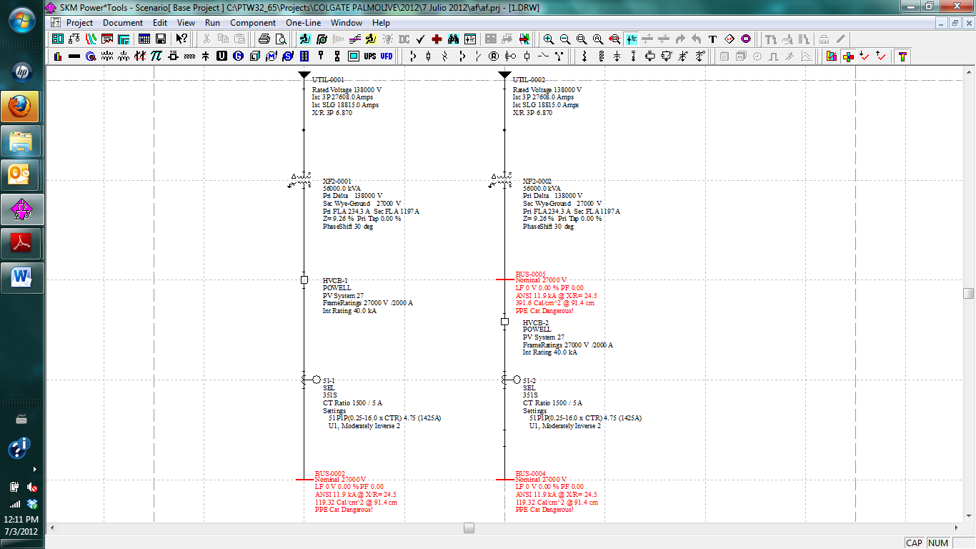
The oneline at right is the same but I included BUS-0005 to show the incident energy upstream the HVCB, which is higher than the downstream.
The so high incident energy is due to the lack of protective device at the primary side of the transformer. You should ask the utility guys about the specs of this device to include it on the oneline.
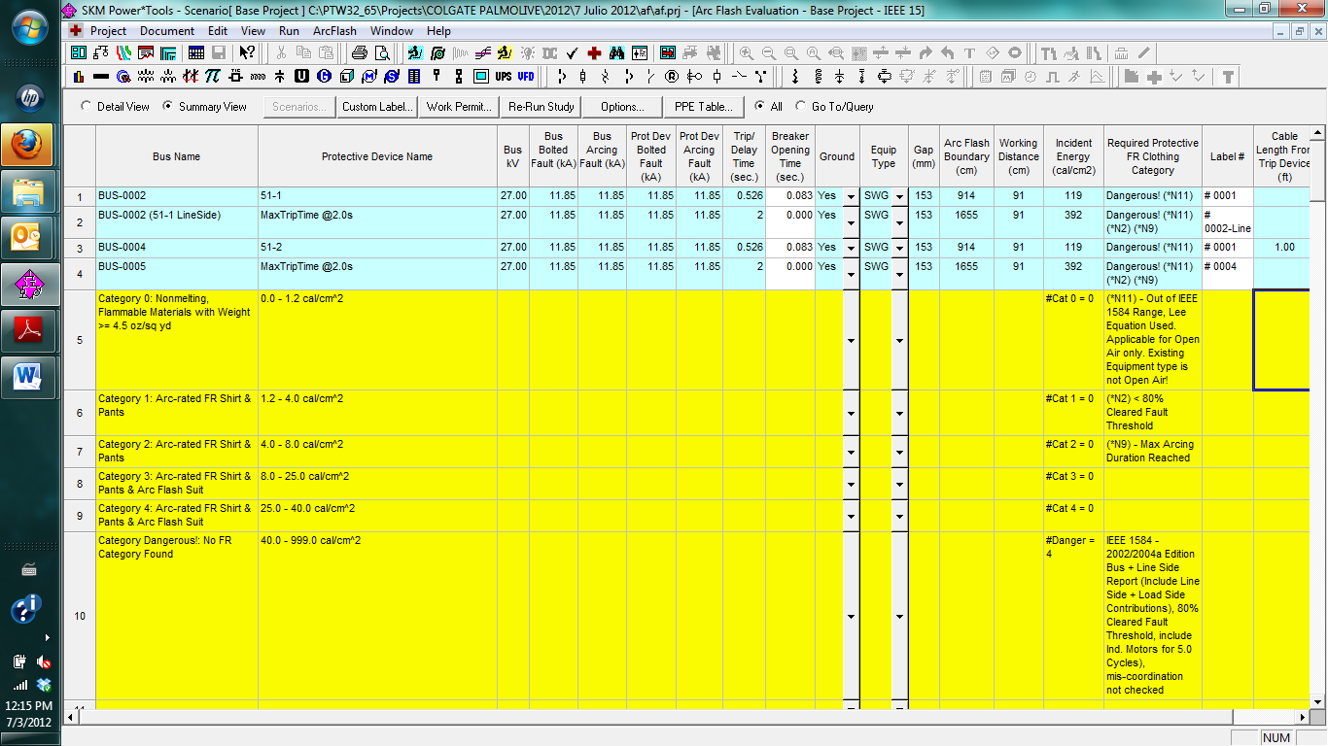
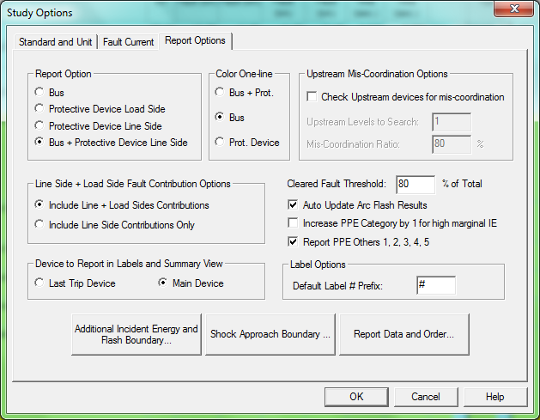
To obtain my results, please look at the selected options.

