Arc Flash Hazards Analysis vs. NFPA 70E Table
There are reasons to use either method for determining the potential hazards before performing electrical work. On the surface, when an electrical contractor walks into a new client’s office, the table method appears the best approach to use. It’s recognized that there are few options. Many owners of building, industrial plants, educational facilities, electric generating facilities and on and on have not taken the time to performed detain arc flash hazards analysis. So what does the electrical contractor do? The same applies to the electrical mai9ntenance technicians in the above listed facilities?
To make the choice y0ou need to understand the pros and cons of each method and then decide upon the level of risk you want to take.

NFPA 70E Table 130.7(C)(15)(A)(a)
Pros:
- Simple to us
- Low cost

Cons:
- The reliability of the protection of personnel is questionable.
- The necessary information needed to make the calculations required by NFPA 70E to use Table 130.7(C)(15)(A)(a) is not readily available.
- Manual calculations on only a small part of an electrical system risk serious errors unless you consider operating conditions of the facility.
- You cannot determine the operating time of an overcurrent protective device without the use of a time current curve. Are they available?
- Performing the necessary calculations and analysis necessary to determine if the amount of short circuit current and the overcurrent protection device tripping time for all the major electrical panels in a facility will take almost as much time as doing an arc flash hazard analysis.

Arc Flash Hazards Analysis
Pros:
- An arc flash hazards analysis required the use of up to date one-line (single-Line) diagrams. Verifying of one-line diagrams is a side benefit of the study.
- An arc flash hazards analysis required a short circuit analysis be performed. This is also a side benefit and it is a good idea to review this data to insure that electrical equipment Has the required rating of maximum available short circuit data.
- An arc flash hazards analysis required the collection of overcurrent protection device data.
- An arc flash hazards analysis provided detail documentation of the facility’s electrical system which is always a benefit.
- An arc flash hazards analysis provided a software model which provides a great too for the future when facility expansion is considered.
- An arc flash hazards analysis provides easy tools for the evaluation of arc flash hazard/risk mediation
- Within minutes questions concerning the adjustment of overcurrent protective devices can be reviewed to determine if risk well increase.
- When the electrical maintenance staff participates in the collection of the needed data for an arc flash hazards analysis, they begin to feel that the company cares.
Cons:
- Cost.
- Time.

Quantifying the reliability of NFPA 70E Table 130.7(C)(15)(A)(a)

Example 1
This example is for one of four locations in one plant.
2500 kVA Transformer
5.79 % Impedance
480 volts Secondary
Delta/Wye
3000 Amp Gould Shawmut class L Fuse, Model No. A4BQ
Short circuit current = 52.345 kA
Arc Fault Current = 24.999 kA
Incident Energy = 78.9 cal/cm² - by arc flash analysis > category 4, Dangerous
Table 130.7(C)(15)(A)(b) other 600-V class equipment , maximum of 65 kA short circuit current - category 2
This is a very dangerous situation where very serious injuries are likely. Table method will NMOT protect, death is likely.

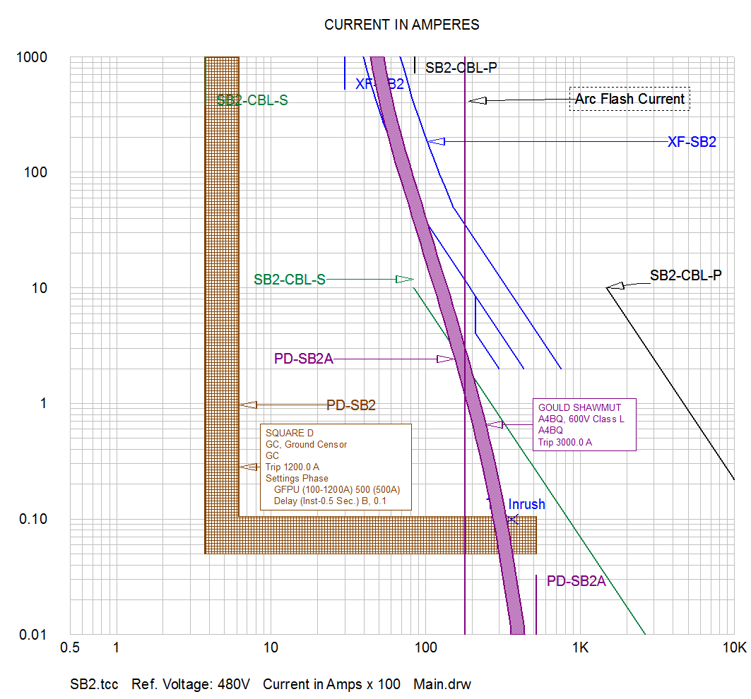

Example 2

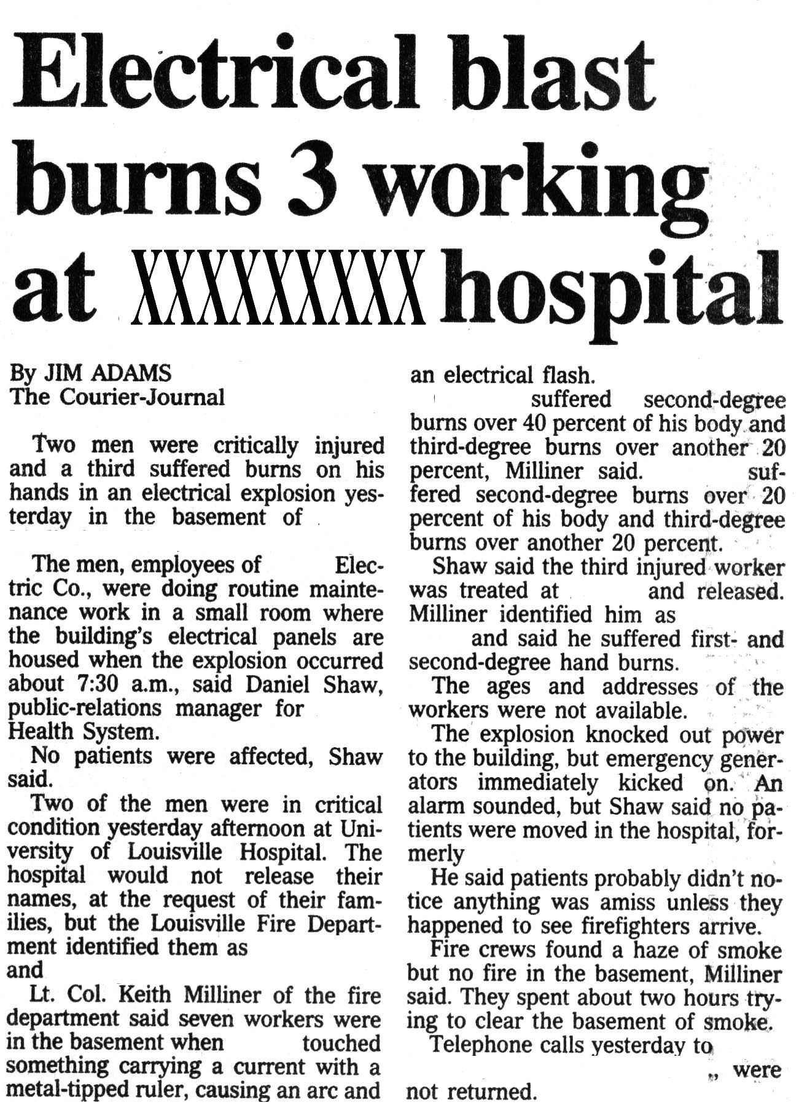
- Louisville, August 4, 1996
- 3 electricians involved in an Arc Flash
- 2000 Amp busduct (1500 kVA Transformer, 1804 amps full load, 5.5%, 32,800 amps short circuit current)
- Protected by 2500 Amp current limiting fuse.
- I_{AF} = ~14,540 Amps (arc flash current)
- Bussmann KRP 2500
- Fuse clears the fault in 4 seconds (4000ms, but should have cleared in <4 ms)
- Incident Energy = 196 cal/cm² (open air)
One electrician dead after 11 days in hospital. Note, happened 1996 before the NFPA 70E standard included arc flash. Category 2 PPE per table method. Category 2 would not have provided a lot of protection against 129 cal/cm².
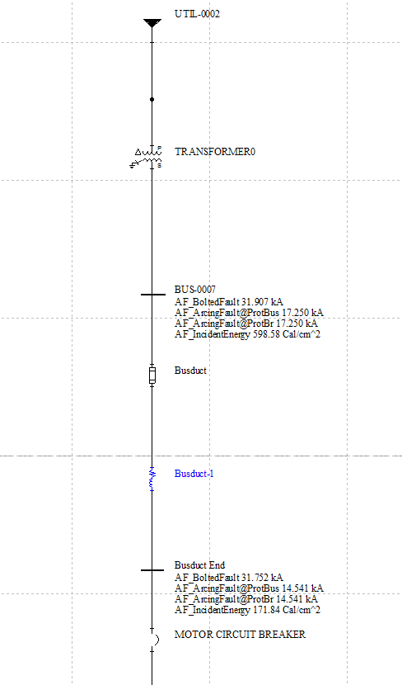
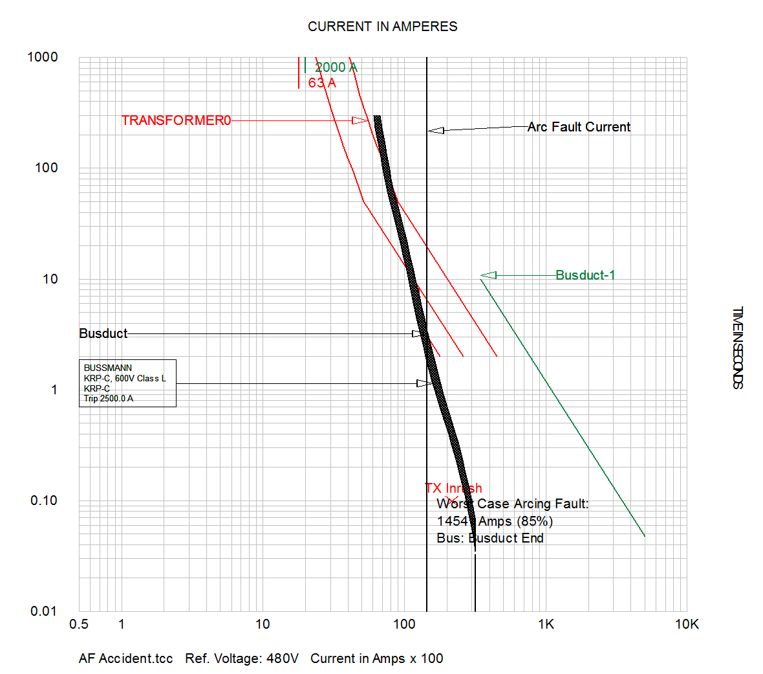

Institute of forensic Electro-Pathology
http://www.vinita.biz/Electrical-Accidents.html

